Student Name: Phi Hung Cao

Student ID: 300279621

I confirm that my program is complete and working. I have implemented all required features

CSIS3540 Client SERVER SYStem

DBLab3: Product Look

Source Code:

Step1: Connecting datatable

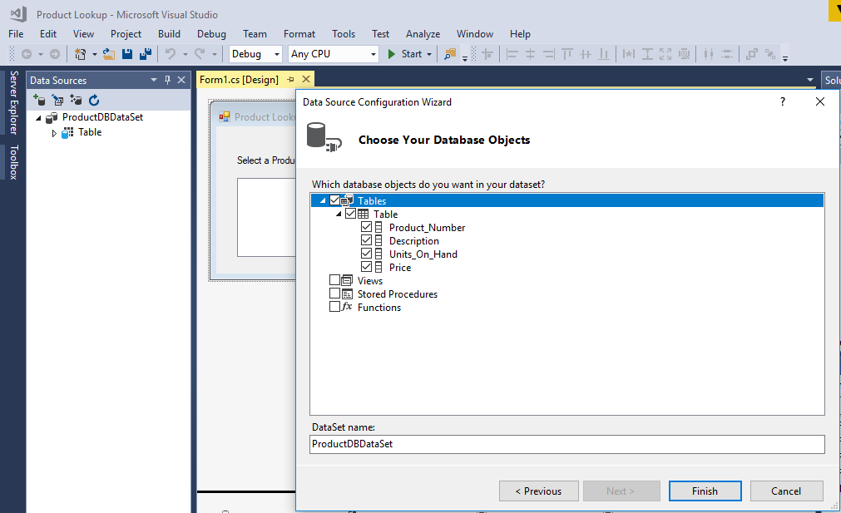

Step3: Create data detail view

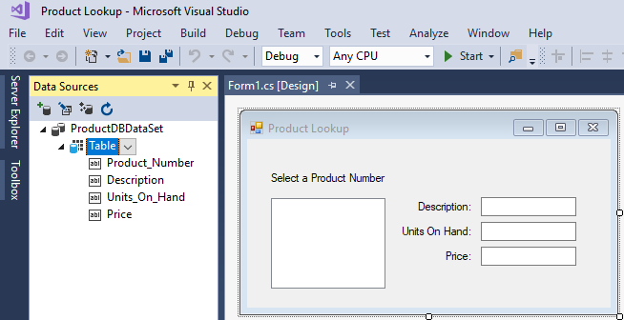

Output:

